**Data Science for Engineers**

**Lab Report 5**

**Hafiz Ahmad**

**19l-1316**

**Section-7A**

**Data visualization**

**INTRODUCTION:**

Data visualization is the graphical representation of different pieces of information or data, using visual elements such as charts, graphs, or maps. Data visualization tools provide the ability to see and understand data trends, outliers, and patterns in an easy, intuitive way. There are many types of data visualization. The most common are scatter plots, line graphs, pie charts, bar charts, heat maps, area charts, choropleth maps and histograms.

**OBJECTIVES:**

• To know about data visualization.

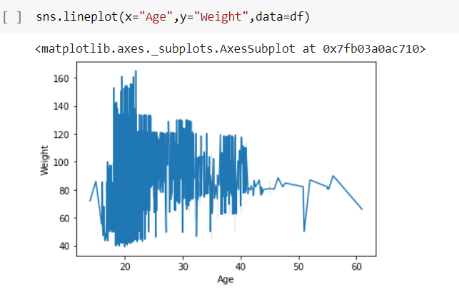

**Application:**

The Data visualization helps to tell stories by curating data into a form easier to understand, highlighting the trends and outliers. A good visualization tells a story, removing the noise from data and highlighting useful information.

**Issues:**

we never find any issue regarding this lab.

**Conclusion:**

In this lab data visualization should communicate a data set clearly and effectively by using graphics. The best visualizations make it easy to comprehend data briefly.